CASE STUDY ON ENVIRONMENT, NATURAL RESOURCES AND SUSTAINABLE LIFESTYLE

Submitted by: YUVRAJ VINAYAK SURYAWANSHI
Class/Roll No.: 181
Subject: Environmental Studies
Academic Year: 2026-2027

INDEX

Sr. No. Topic Page No.
- Introduction: Definition and Scope of Environment
1
2
3

4
5
6
7

- Importance of Environment and Components
- Need for Public Awareness
- Natural Resources: Renewable and Non-Renewable Resources
- Natural Resources and Associated Problems
- Role of Individuals in Conservation
- Sustainable Lifestyle and Conclusion

INTRODUCTION: DEFINITION AND SCOPE OF ENVIRONMENT

Definition of Environment
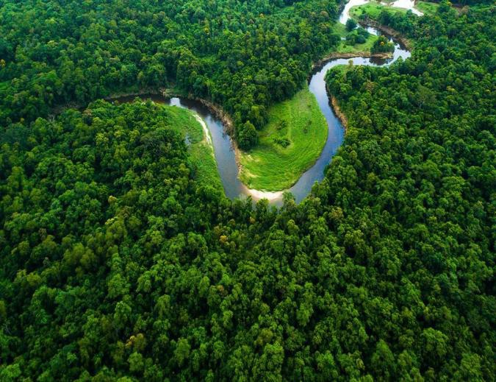
The environment refers to the surroundings in which living organisms exist and interact. It includes all living and non-living components such as air, water, soil, plants, animals, and human beings. The environment provides essential resources required for survival and supports different forms of life on Earth.
Environment is a combination of natural and human-made surroundings that influence the growth,development, and activities of organisms Environment is a combination of natural and human-made surroundings that influence the growth, development, and activities of organisms. Therefore, protecting the environment and using natural resources responsibly is essential for sustainable development and for ensuring a healthy future for present and future generations.
Fig. 1: Forest Ecosystem and Natural Resources

Scope of Environment
Environmental Studies is a multidisciplinary subject that focuses on understanding the relationship between humans and nature. It includes the conservation of natural resources, protection of biodiversity, pollution control, climate change awareness, sustainable development, and ecosystem management. The study of the environment helps people understand how human activities affect nature and encourages the responsible use of natural resources.


Fig. 2: Renewable Energy Sources – Solar and Wind Energy

2. IMPORTANCE AND COMPONENTS OF ENVIRONMENT

Importance of Environment
The environment is essential for the survival and well-being of all living organisms. It provides the basic resources needed for life, such as air, water, food, forests, minerals, and energy. These natural resources support human activities, agriculture, industries, and economic development.
The environment also helps maintain ecological balance by regulating the climate, preserving biodiversity, and supporting healthy ecosystems. Forests, rivers, and other natural habitats provide shelter for millions of plant and animal species, ensuring the continuity of life on Earth. Therefore, protecting the environment is necessary for sustainable development and for securing a healthy future for present and future generations.
.

Components of Environment
The environment is made up of four major components that work together to support life on Earth. Each component plays an important role in maintaining ecological balance and providing the resources needed for the survival of living organisms.

Atmosphere
The atmosphere is the layer of gases surrounding the Earth. It provides oxygen for breathing, regulates the Earth's temperature, and protects living organisms from harmful ultraviolet (UV) radiation from the sun.

Hydrosphere
The hydrosphere includes all forms of water found on Earth, such as oceans, rivers, lakes, ponds, glaciers, and groundwater. It is essential for drinking, agriculture, industries, and maintaining the water cycle that supports all forms of life.

Lithosphere
The lithosphere is the solid outer layer of the Earth, consisting of soil, rocks, and minerals. It provides land for agriculture, human settlements, forests, and industries, while also supplying valuable mineral resources.

Biosphere
The biosphere is the region where all living organisms, including plants, animals, and microorganisms, exist and interact with the atmosphere, hydrosphere, and lithosphere. It supports biodiversity and maintains the balance of ecosystems.

NEED FOR PUBLIC AWARENESS
Environmental problems are increasing due to population growth, industrialization, deforestation and overuse of resources. Public awareness is necessary to encourage people to protect nature.

Environmental awareness is important because it helps people understand the need to protect nature and use natural resources responsibly. It encourages individuals to reduce pollution, conserve water, save energy, and protect forests and wildlife. Awareness also promotes sustainable development by ensuring that natural resources are used wisely for future generations.
Environmental awareness programs conducted through schools, media, and government campaigns educate people about environmental issues and encourage them to adopt eco-friendly habits. Activities such as tree plantation drives, waste management programs, and water conservation campaigns inspire community participation and contribute to a cleaner and healthier environment.


Fig 3.Environmental awareness campaign

NATURAL RESOURCES
Natural resources are materials obtained from nature that are useful for humans and other organisms. They are essential for economic development and survival.

Types of Natural Resources

Renewable Resources
Renewable resources are natural resources that can be replenished or regenerated naturally within a relatively short period of time. These resources are considered sustainable because they can be used repeatedly without being permanently exhausted if managed properly.
Examples of renewable resources include solar energy, wind energy, water, and forest resources. The use of renewable resources helps reduce pollution, provides a continuous supply of energy and materials, and supports sustainable development by minimizing environmental damage.

Non-Renewable Resources
Non-renewable resources are natural resources that exist in limited quantities and take millions of years to form. Once these resources are used, they cannot be replaced within a human lifetime. Examples include coal, petroleum, natural gas, and minerals. Excessive use of non-renewable resources leads to resource depletion, environmental pollution, and climate change. Therefore, it is important to use these resources wisely, promote recycling, and encourage the use of renewable alternatives whenever possible.

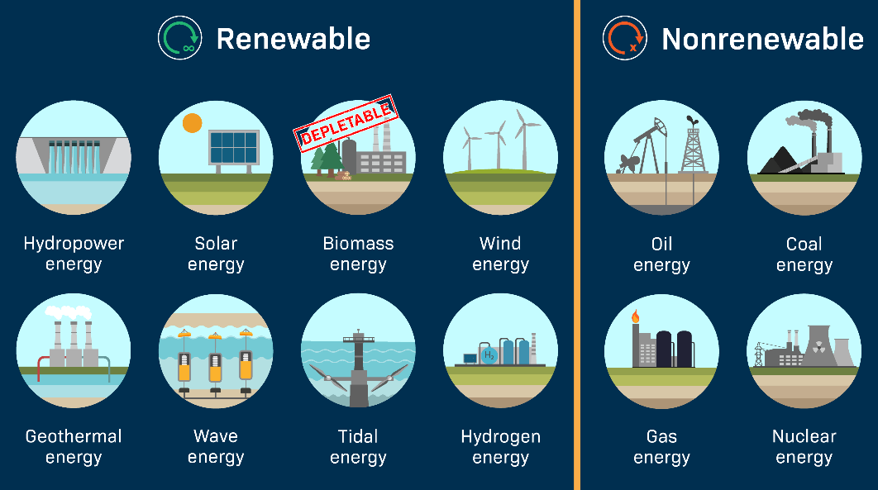
Fig 4..Renewable and Non Renewable energy

1.NATURAL RESOURCES AND ASSOCIATED PROBLEMS

A. Forest Resources
Forest resources are among the most valuable natural resources, providing oxygen, timber, medicines, wildlife habitat, and helping to regulate the climate. However, deforestation, loss of wildlife habitats, soil erosion, and
climate change have become major threats to forests. These problems can be controlled through afforestation, strict forest protection laws, and sustainable forest management. Conserving forests is essential for maintaining biodiversity and ensuring a healthy environment for future generations.

B.Water Resources
Water is one of the most important natural resources and is essential for drinking, agriculture, industries, and energy production. However, water pollution, groundwater depletion, and increasing water scarcity have become major environmental concerns. These problems can be reduced through rainwater harvesting, preventing unnecessary water wastage, and recycling water. Conserving water resources ensures a sufficient supply of clean water for present and future generations

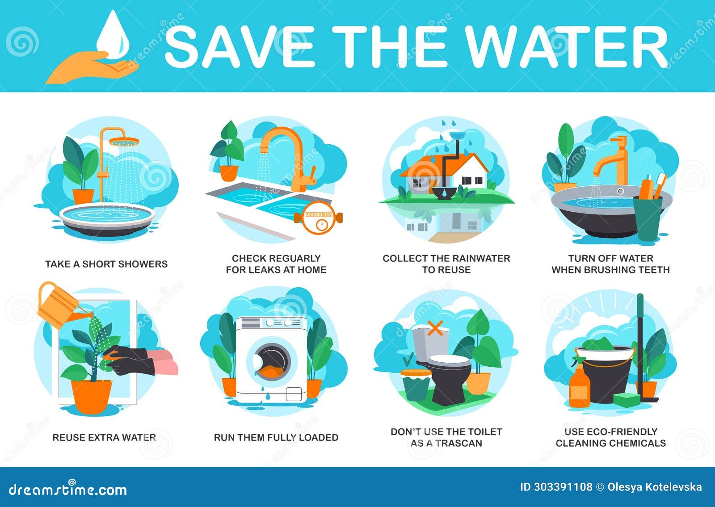

FIG.5.WATER RESOURCES

Mineral Resources
Mineral resources such as iron, copper, and coal are essential for industrial growth and economic development. However, excessive mining, land degradation, and pollution caused by mining activities have harmful effects on the environment. These problems can be minimized through controlled mining practices and by recycling metals to reduce the demand for new mineral extraction. Conserving mineral resources ensures their availability for future generations while protecting the environment.

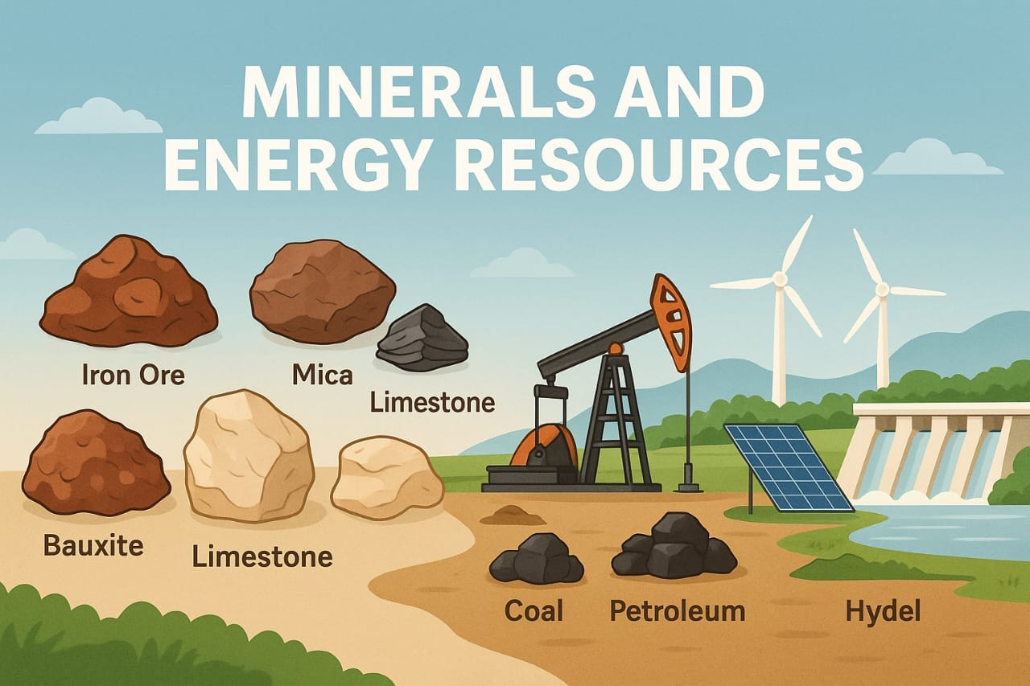

FIG 6.MINERALS RESOURCES

Food Resources
Food resources include crops, livestock, and fisheries, which are essential for human survival and economic development. However, increasing population, excessive use of pesticides, and soil degradation have created serious challenges for food production. These problems can be reduced by adopting organic farming, practicing sustainable agriculture, and minimizing food waste. Conserving food resources helps ensure food security and protects the environment for future generations.

•

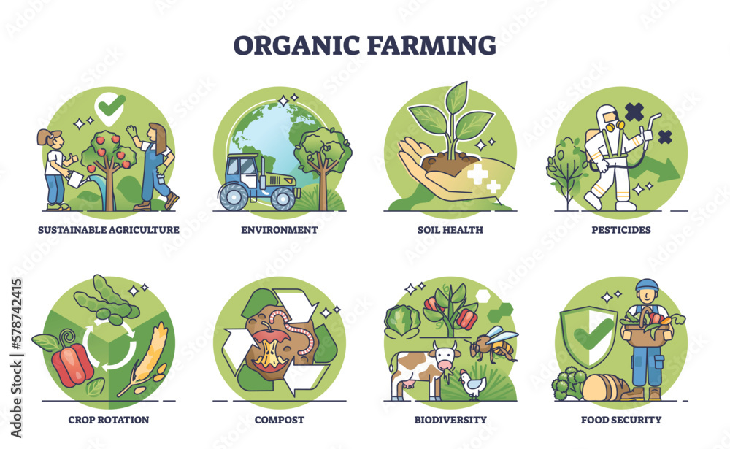
FIG.7.FOOD RESOURCES

E.Land Resources
Land is an essential natural resource that supports agriculture, forests, industries, and human settlements. However, increasing human activities have led to problems such as soil erosion, desertification, and rapid urbanization, which reduce land quality and productivity. These problems can be controlled through proper

land management, soil conservation methods, and plantation activities. Conserving land resources helps maintain ecological balance and ensures their sustainable use for future generations.

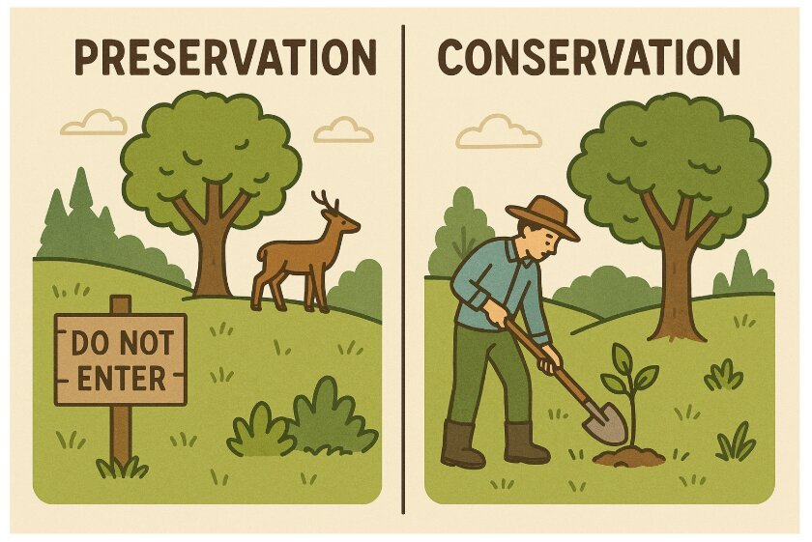
FIG.8.LAND PRESERVATION AND CONSERVATION

F.Energy Resources
Energy resources are essential for transportation, industries, agriculture, and daily life. However, excessive use of fossil fuels has led to serious problems such as air pollution and global warming. These issues can be reduced by using renewable energy sources like solar and wind power, saving electricity, and promoting energy-efficient technologies. Conserving energy resources helps protect the environment and ensures a sustainable future.

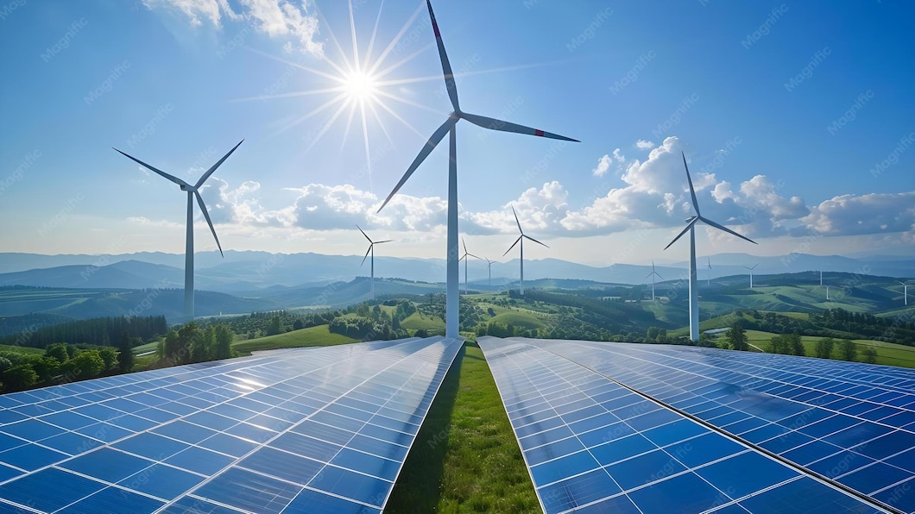
FIG.9.ENERGY RESOURCES (SOLAR PANELS)

ROLE OF AN INDIVIDUAL IN CONSERVATION OF NATURAL RESOURCES
Every individual has an important role to play in the conservation of natural resources. Since natural resources such as water, forests, minerals, and energy are limited, their responsible use is essential for maintaining ecological balance and ensuring their availability for future generations. Small actions taken by individuals in daily life can collectively make a significant contribution to environmental protection.

One of the simplest ways to conserve natural resources is by saving water and avoiding unnecessary wastage. Planting and protecting trees helps improve air quality, conserve biodiversity, and reduce the effects of climate change. Reducing the use of plastic and adopting reusable alternatives minimizes pollution and protects wildlife from harmful plastic waste.

Individuals can also contribute by reusing and recycling materials, which helps reduce the demand for raw resources and decreases the amount of waste sent to landfills. Choosing public transportation, cycling, or walking instead of using private vehicles reduces fuel consumption and lowers air pollution. Saving electricity by switching off lights and electrical appliances when they are not in use also helps conserve energy and reduce greenhouse gas emissions.

Participating in environmental awareness campaigns, tree plantation drives, and other conservation programs further strengthens community efforts toward protecting nature. When individual responsibility is combined with collective action, it creates a positive impact on the environment and promotes sustainable development for present and future generations.

USE OF RESOURCES FOR A SUSTAINABLE LIFESTYLE
A sustainable lifestyle means using natural resources responsibly without harming future generations.

Ways to Follow a Sustainable Lifestyle

A sustainable lifestyle refers to the responsible and efficient use of natural resources in a way that meets present needs without compromising the ability of future generations to meet their own needs. As the world's population continues to grow and the demand for resources increases, it has become essential to adopt sustainable practices that help conserve the environment and maintain ecological balance.
Using natural resources wisely reduces pollution, minimizes waste, and protects biodiversity. One of the most effective ways to promote sustainability is by using renewable energy sources such as solar and wind energy instead of fossil fuels. Practicing waste segregation and following the principles of Reduce, Reuse, and Recycle (3Rs) help decrease the amount of waste sent to landfills and encourage efficient resource utilization.
Purchasing eco-friendly products, reducing unnecessary consumption, and avoiding single-use plastics further contribute to environmental conservation. Protecting forests, wildlife, and other natural ecosystems is equally important, as biodiversity plays a vital role in maintaining the balance of nature.
By adopting sustainable habits in our daily lives, we can reduce our environmental impact, conserve valuable natural resources, and ensure a cleaner, healthier, and more sustainable future for present and future generations

CONCLUSION
The environment is the foundation of life on Earth. Natural resources provide humans with everything needed for survival and development. However, excessive exploitation has created serious environmental problems.
Conservation of resources requires awareness, responsible behavior, and sustainable practices. Every individual has an important role in protecting nature. By adopting an environmentally friendly lifestyle, we can create a healthier and more sustainable future.

References
  - Environmental Studies textbooks
  - NCERT Environmental Science resources
  - Government environmental awareness materials
4. Sustainable development reports

